`

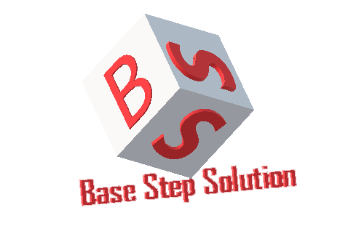

Software Architectural Process Architectural Process

Van Lang Admissions

# Revision Table

|  |  |  |  |
| --- | --- | --- | --- |
| **Author** | **Date** | **Reason for changes** | **Version** |
| Tai Nguyen | 2/11/2016 | Architectural Process | 1.0 |
| Khoi Nguyen | 24/5/2017 | Fix template | 2.0 |

Table of Contents

Revision Table 1

1. INTRODUCTION 3

1.1. Purpose 3

1.2. Audience 3

2. Process 3

2.1. Process flow 3

2.2. Activities 3

2.3. Roles and Responsibility 3

2.4. Process Decision 3

# INTRODUCTION

## Purpose

Overview about architect of Project, help team understand about architect of Project

## Audience

The intended audience of the AR Plan is

|  |  |
| --- | --- |
| **Intended Audience** | **Description** |
| All team member | All member have a meeting and discuss about process |
| The mentor | People give an advice and support group during Architect process. |
| Stakeholder on customer side | People give requirement of project |
|  |  |

# Process

## Process flow

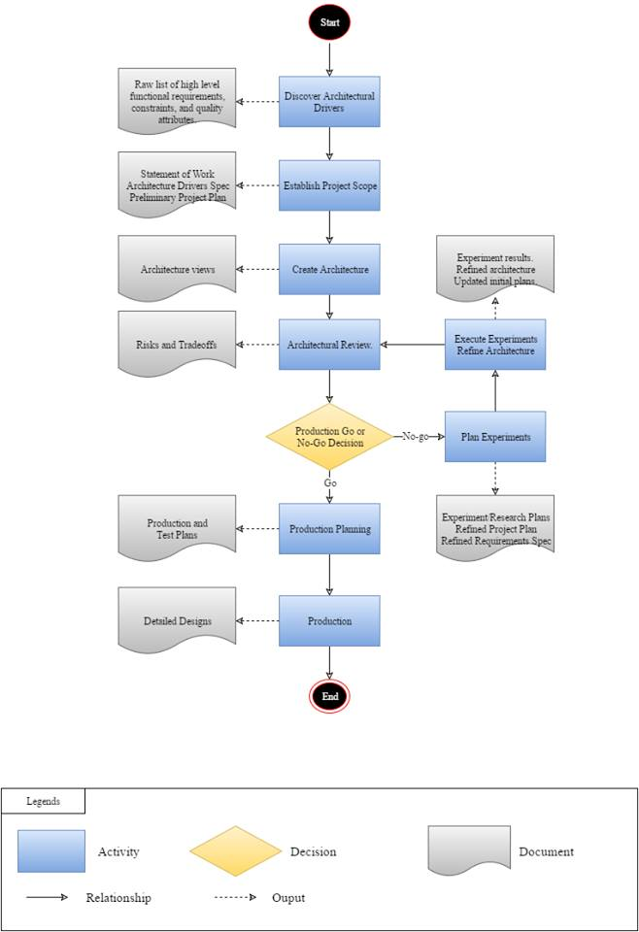

## Activities

|  |  |  |  |
| --- | --- | --- | --- |
| **Stage** | **Description** | **Activities** | **General output** |
| 1 | **Discover architecture driver:** | The architecture team will meet with the system stakeholder to discover and document architecture driver. We are not focus about refinement, analysis, or structuring information but rather about gathering as much information as possible. | Raw list of high level functional requirements, constraints, and quality attribute |
| 2 | **Establish project scope:** | Distill architectural drivers into an architectural drivers specification. Create a Statement of Work and Preliminary Project Plan. Qualities attribute. | - Statement of Work  - Architecture Drivers Spec  - Preliminary Project Plan |
| 3 | **Create Architecture:** | Create the initial architecture which includes a run-time view, code view, and physical view of the system. | Architecture Views |
| 4 | **Architecture Review:** | Review the notional architecture to discover and document risks and issues. | Risks and tradeoffs |
| 5 | **Production Go/No-Go:** | Prioritize and list the risks and issues discovered during the architecture review and decide whether the architecture is ready for production (production step 6) or whether it needs to be refined (refine step 6). |  |
| 6 | **Plan Experiments** | Team creates experiments to mitigate risks and/or issues that were discovered during the review. Experiments are targeted, planned, technical prototypes that are for the purpose of exploring technical issues associated with the architecture or to further explore the architectural drivers. | Experiment research plans  Refined Project Plan  Refined Requirements Spec |
| 7 | Experiment Execution and Architecture Refinement | The team carries out the experiments and documents the results. The architecture is refined based on the results of the experiments. | Experiment results  Refined architecture  Update initial plans |
| 8 | **Product Planning:** | Team creates a detailed plan for the construction of the system based on the refined architecture. Each element of the architecture has an “owner” and shepherds the construction of the element to completion. The plan schedules time and resources for detailed element design, reviews, construction, test, and so forth.. | Production and Test Plan |
| 9 | **Production** | The team executes the production plan and is actively engaged in building the system. Production includes construction of the elements of the architecture, integration of the system, as well as element and system test. Production may result in producing the whole system, parts of the system, or in deliverable increments of the system. | Detailed Design |

## Roles and Responsibility

|  |  |  |
| --- | --- | --- |
| **No** | **Role** | **Responsibility** |
| 1 | Project Manager | Is responsible for coordinating the overall system design and development effort. They also solve problem between stakeholder. |
| 2 | Architect Leader | Is responsible for architecture design. |
| 3 | Requirement Engineer | Is responsible for leads the effort to gather requirement. Support develop document the architectural drivers. |
| 4 | Architecture team | Is support team design the architecture. |